VA/NVA Platform – Temporal Action Segmentation Integration (Group 1)
The goal is to explain the system clearly and precisely in simple terms, so that mentors, reviewers, and new team members can easily understand how the platform works.

1. Problem Overview
Industrial time-study videos are long and complex. Manually identifying what actions workers perform (such as fill, wait, or walk) and whether those actions add value (VA) or not (NVA) is time-consuming and error-prone. The platform aims to automate this analysis and present all insights in a single, unified UI.

2. System Architecture
The platform follows a backend-driven architecture. Videos are uploaded once and processed entirely on the backend. Machine learning models never interact with the frontend directly. Instead, the backend exposes clean, versioned APIs that the frontend uses only for visualization.
There are three logical layers:
1. Frontend (Visualization Layer)
2. Platform Backend (Integration & Orchestration Layer)
3. ML Modules (Tracking and Temporal Segmentation)

4. Temporal Action Segmentation – Research Summary
The Temporal Action Segmentation module recognizes actions over time in long videos. Early frame-based approaches were unstable and noisy. To solve this, a two-stage pipeline was designed.
Stage 1: Feature Extraction
- Video frames are sampled at a fixed FPS
- Frames are grouped into short clips
- Each clip is passed through a pre-trained I3D model
- A 2048-dimensional feature vector is extracted per clip
Stage 2: Temporal Modeling
- Extracted features are passed into an MS-TCN model
- The model predicts action segments over time
- Output is stable, continuous segments instead of noisy frame-level labels
Feature extraction runs on CPU to avoid GPU memory issues. Clip-center timestamps are used to correctly align features with video time.

5. Why This Design Was Chosen
This design was chosen because it balances performance, stability, and scalability. By separating feature extraction and temporal modeling, the system avoids memory crashes and supports long videos. Segment-level outputs are easy to visualize and understand for non-technical users.

6. Role of the Platform Team
The Platform Team owns the overall integration. This includes job management, data storage, API design, timeline aggregation, KPI computation, and frontend wiring. The platform treats outputs from other teams as plug-in data sources.

7. Data Flow (End-to-End)
1. User uploads a video through the UI
2. Backend creates a job and stores the video
3. Backend triggers the tracking module (Team 2)
4. Backend triggers the temporal segmentation module (Team 3)
5. Outputs are validated and stored in the database
6. Backend aggregates all outputs into a unified timeline
7. Frontend fetches timeline and KPIs and renders them

8. Database Design Rationale
A relational database design was chosen to ensure consistency and easy querying. The job_id acts as the primary join key across all tables. All data is timestamp-based, enabling precise timeline alignment.
Key tables include:
- jobs: tracks video processing lifecycle
- worker_tracks: stores per-frame worker location and zone
- zone_events: stores entry, exit, and cross-zone events
- va_nva_segments: stores VA/NVA intervals
- temporal_segments: stores action segments with confidence

9. Why This Database Design Works
This schema cleanly separates concerns while remaining easy to extend. New ML modules can add tables without affecting existing ones. Because all records align to video time, the frontend can merge and visualize them on a single timeline without complex transformations.

10. Frontend Integration Philosophy
The frontend is purely a visualization layer. It does not perform ML inference or frame processing. It renders video, overlays bounding boxes, displays timelines, and shows KPIs. This keeps the UI fast, simple, and scalable.

11. Conclusion
This platform design provides a robust and industry-grade foundation for VA/NVA analysis. By centralizing integration in the backend and standardizing data contracts, the system enables multiple ML modules to work together seamlessly in a single UI. The architecture is modular, scalable, and well-suited for future expansion.

Frontend Tech Stack
Core
- React + Next.js
- TypeScript
Backend Tech Stack
Language
- Python
API Framework
- FastAPI
  - Versioned APIs (/v1/)
  - Async job status

Storage
- Filesystem (videos, outputs)
- PostgreSQL (structured timeline data)

Data Flow
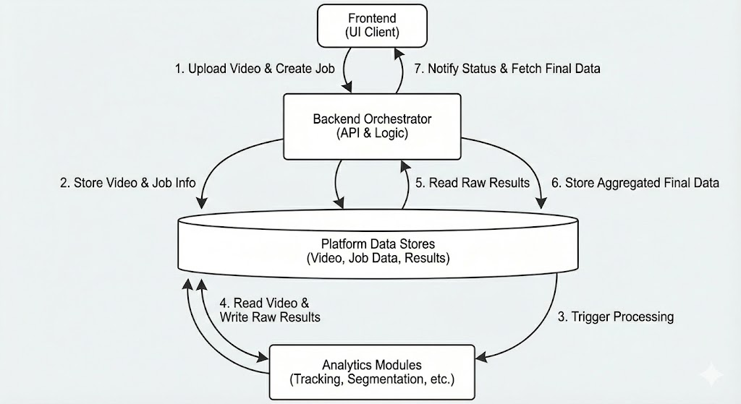
B. Storage & Database Design
Tables
1️⃣ jobs
job_id
video_path
status
created_at

2️⃣ worker_tracks (from Team-2)
job_id
worker_id
timestamp
bbox
zone_id

3️⃣ zone_events (from Team-2)
job_id
worker_id
zone_id
event_type -- entry / exit / cross_zone
start_time
end_time
reason

4️⃣ va_nva_segments (rule-based or merged)
job_id
worker_id
start_time
end_time
type -- VA / NVA
source -- rule / temporal

5️⃣ temporal_segments (from Team-3)
job_id
worker_id (nullable)
start_time
end_time
action_label
confidence

